DANCE CLASSES RISK ASSESSMENT
CARRIED OUT BY:
mobile phone no.:
Complete the following table:
1. Rate each risk’s severity on scale from: Negligible (N), Low risk (L), Moderate risk (M), Severe (S), Very severe (V)
2. Rate each risk’s likelihood on scale from: Very unlikely (VU), Unlikely (U), Possible (P), Likely (L), Very likely (VL)
3. Determine the risk factor from the table overleaf.
Hazard
Back and Muscle Injury
Present?
Severity
Likelihood
Risk
Factor
1
2
3
4
5
6
YES
L
L
L
U
3
3
3
3
3
3
Cuts, bruises, breaks, strains, grazes
Fainting/passing out (from heat/exhaustion)
Electric shocks from equipment
Slipping on liquid spills
YES
YES
YES
YES
YES
U
U
P
U
U
M
L
Choking on food
L
Risk Factor:
Very Unlikely
Unlikely
Possible
Likely
Very Likely
Very severe
Severe
Moderate
Slight
3
2
2
1
1
4
3
2
2
1
4
3
3
2
2
5
3
3
3
2
5
5
3
3
3
Negligible
Action to take:
5
4
3
2
1
Very severe
Severe
Moderate Risk
Low Risk
Take immediate action
High priority
Program for action
Action may be required
Probably acceptable
Negligible
Risks identified:
Hazard no:
Description
1
Risk Factor (1-5)
3
Back and muscle injury
Person(s) exposed
Action to take
Teacher, Dancers
Teachers are trained
Everyone to warm up thoroughly
Dancers are given moves suitable to their age and ability
Hazard no:
Description
2
Risk Factor (1-5)
3
Cuts, bruises, breaks, strains, grazes
Person(s) exposed
Action to take
Teacher, Dancers
Children to be supervised at all times
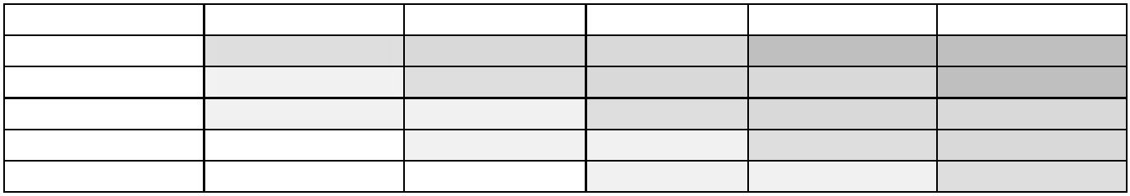

Hazard no:
Description
3
Risk Factor (1-5)
3
Fainting/passing out (from heat/exhaustion)
Person(s) exposed
Action to take
Teacher, Dancers
Teacher and Dancers to take regular breaks and keep hydrates
throughout the class.
Hazard no:
Description
4
Risk Factor (1-5)
3
Electric shocks from equipment
Person(s) exposed
Action to take
Teacher, Dancers
Only trained and competent persons to use this equipment
Hazard no:
Description
5
Risk Factor (1-5)
3
Slipping on liquid spills
Person(s) exposed
Action to take
Teacher, Dancers
Drinks to be kept to separate area. Spills to be cleared immediately
Hazard no:
Description
6
Risk Factor (1-5)
3
Choking on food
Person(s) exposed
Action to take
Teacher, Dancers
Food/sweets to only be consumed in breaks and sitting down
Children to be supervised at all times
If the producer has not completed the risk assessment, then they should countersign this form.
Completed by: Vicky Codling Position: Owner

